ITA0408-STATISTICS WITH R PROGRAMMING
EXPERIMENTS

Create numeric, character, and logical vectors and display type and content.

Aim:
To create numeric, character, and logical vectors and display type and content.

Procedure:
Step 1: Open RStudio or R console on your system.
Step 2: Create a numeric vector containing numerical values.
Step 3: Display the contents of the numeric vector on the screen.
Step 4: Use the class function to check and print the data type of the numeric vector.
Step 5: Create a character vector containing names or text values.
Step 6: Display the contents of the character vector.
Step 7: Use the class function to identify and print the data type of the character vector.
Step 8: Create a logical vector containing TRUE and FALSE values.
Step 9: Display the logical vector on the screen.
Step 10: Use the class function to print the data type of the logical vector.
Step 11: Observe and note that numeric, character, and logical vectors each have distinct data types.

OUPTUT SCREENSHOT:
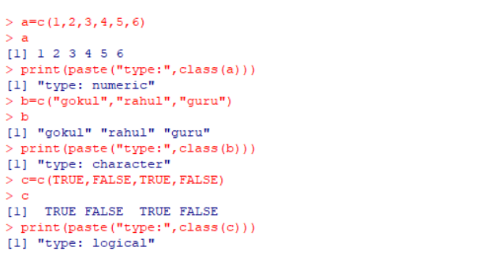

Exp 2: Create labeled matrices (5×4, 3×3, 2×2) filled by row/column.

Aim:
To create labeled matrices (5×4, 3×3, 2×2) filled by row/column.

Procedure:
Step 1: Open RStudio or R console on your system.
Step 2: Create a matrix by arranging a sequence of numbers into rows and columns. Step 3: Display the created matrix to check its elements and layout.
Step 4: Create another matrix with a different size (for example, 3×3) to understand matrix creation with various dimensions.
Step 5: Display the second matrix to verify its arrangement.
Step 6: Create a smaller matrix (for example, 2×2) to observe how matrix size can vary. Step 7: Display the third matrix to view its content.
Step 8: Observe that each matrix organizes elements in a rectangular form with equal- length rows and columns.

OUTPUT SCREENSHOT:
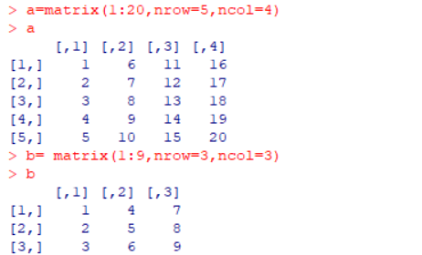
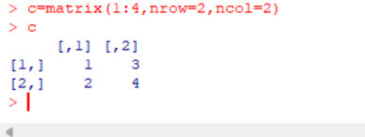

Write an R program to create and display a 3D array with specified rows, columns, and tables.

Aim:
To write an R program to create and display a 3D array with specified rows, columns, and tables.

Procedure:
Step 1: Open RStudio or R console on your computer.
Step 2: Create a sequence of numbers to be stored in a variable.
Step 3: Use that sequence to create a multi-dimensional array by specifying dimensions such as number of rows, columns, and tables.
Step 4: Store the created array in a variable.
Step 5: Display the array to view all the elements arranged across multiple rows, columns, and layers.
Step 6: Observe how an array in R can store data in more than two dimensions, unlike a matrix.

OUTPUT SCREENSHOT:
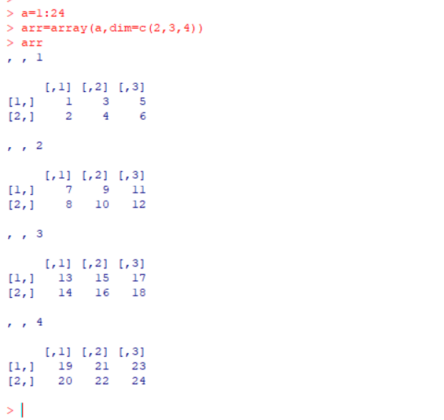

Create arrays from vectors with dimension names, print specific elements.

Aim:
To create arrays from vectors with dimension names, print specific elements.

Procedure:
Step 1: Open RStudio or R console on your system.
Step 2: Create a sequence of numbers and store it in a variable.
Step 3: Use the array function to arrange these numbers into multiple dimensions by specifying the number of rows, columns, and tables.
Step 4: Store the created array in a variable.
Step 5: Display the entire array to view how the elements are arranged in each layer.
Step 6: Access a specific element from the array using its row, column, and table position.
Step 7: Print the selected element to verify correct indexing within the array.

Output screenshot:

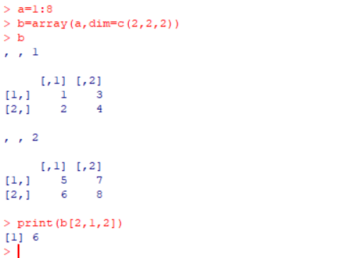

Create and manipulate factor variables (e.g., women’s dataset heights, random LETTERS sample).

Aim:
Create and manipulate factor variables (e.g., women’s dataset heights, random LETTERS sample).

Procedure:
Step 1: Open RStudio or R console on your computer.
Step 2: Create a character vector containing categorical values such as height levels. Step 3: Convert the character vector into a factor to represent it as categorical data.
Step 4: Display the factor to observe that R assigns internal numeric codes to each category.
Step 5: Set a random seed value to ensure that the random sampling results remain the same each time you run the program.
Step 6: Randomly generate a sample of leflers from A to E using the sample function.
Step 7: Convert the generated leflers into a factor to represent them as categorical variables.
Step 8: Print the factor to view the sampled categories and their assigned levels.

Output screenshot:

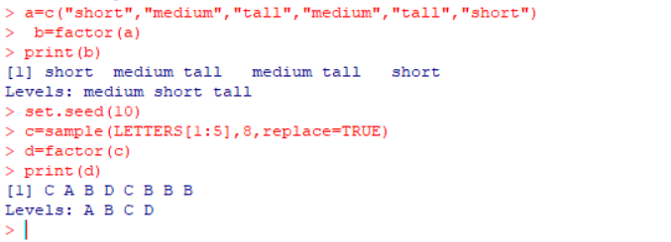

Create an R list containing vectors, matrices, and functions; display contents.

Aim:
To create an R list containing vectors, matrices, and functions; display contents.

Procedure:
Step 1: Open RStudio or R console on your system.
Step 2: Create a numeric vector and store it in a variable.
Step 3: Create a matrix by arranging numbers into specified rows and columns.
Step 4: Define a simple function that performs a mathematical operation (for example, squaring a number).
%%R
a = c(1, 2, 3, 4)
b = matrix(1:6, nrow = 2, ncol = 3)
c = function(x) x^2
mylist = list(Vector = a, Matrix = b, Function = c) print(mylist)

$Vector
$Function
function (x) x^2
Step 5: Combine the vector, matrix, and function into a single list using the list function. Step 6: Assign appropriate names to each component in the list for befler readability.
Step 7: Display the list to view all its components — the vector, matrix, and function — stored together in one structured object.

Output sreenshot:

